GDPR and Privacy Policy for Images Ltd t/a The Littler Places

www.thelittlerplaces.co.uk
Registered address 68 High Street Tarporley Cheshire CW6 0AT
01829 771000
Data Protection Officer Director: Julie Littler

Types of Personal Data Collected:
- The following categories of personal data are collected:
  - Contact information: Name, email address, phone number, etc.
  - Website usage data: IP addresses, browser information, cookies
  - Other information: Any other data collected from individuals (e.g., through forms, surveys, or communications)

Purpose of Data Collection and Processing:
  - Providing requested services
  - Improving user experience
  - Marketing and communication (if applicable)
  - Legal compliance

Legal Basis for Processing:
  - Consent. This is given by signing contracts with data gatherers such as scanners and forms completed at trade fairs.
  - Contractual necessity.
  - Legitimate interests
  - Legal obligation

5. Data Sharing and Disclosure:
- No data is shared without permission. A contact name and delivery address may be provided to our manufacturers if they are to despatch directly. This is within the UK at present but may extend worldwide. If this is to happen, this policy will be updated.
6. Data Retention:
- Data will be retained for up to ten years. If the data isn’t used and customer contact has ceased, the data will be kept for 12 months following cessation.
7. Data Security Measures:
- Data is kept on a secure laptop requiring password access which only the two directors of the company have access to. Regarding email, Mailchimp and its data for The Littler Places is only accessed by director and Data Protection Officer, Julie Littler.

8. Individual Rights:
  - The information is available to the individual under Right to Access
  - The individual has the Right to Rectification
  - The individual has the Right to Erasure (right to be forgotten and/or deleted)
  - The individual has the Right to Restrict Processing
  - The individual has the Right to Object and request changes.
- Individuals can request any of the above in writing or email to hello@thelittlerplaces.co.uk.

9. Cookies and Tracking Technologies:
- Any cookies used on Mailchimp or www.thelittlerplaces.co.uk are shown on the websites and their host companies

10. Policy Updates:
- This privacy policy may be updated periodically, and the policy will show when the last update was made. It will be reviewed every 12 months and signed to say who and when it was reviewed.
- Users will be informed of any changes.

11. Contact Information for Data Protection Queries:
Any questions or concerns regardind data protection must be directed to
Data Protection Officer, Director: Julie Littler
This must be done in writing or by email to hello@thelittlerplaces.co.uk

12. Legal Compliance:
- This policy aligns with UK GDPR and other relevant data protection laws.

Signed:
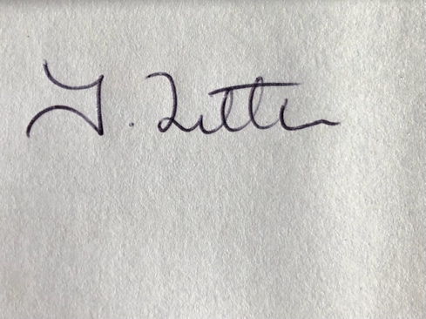
Julie Littler
Director of The Littler Places Date: 24/07/2025
Review Date: 24/07/2026

